**Design & Technology**

**

**Inclusive design**

**Materials required for questions**

* Pencil
* Rubber
* Calculator

**Instructions**

* Use black ink or ball-point pen
* Try answer all questions
* Use the space provided to answer questions
* Calculators can be used if necessary
* For the multiple choice questions, circle your answer

**Advice**

* Marks for each question are in brackets
* Read each question fully
* Try to answer every question
* Don’t spend too much time on one question

**Good luck!**

**Q1.** What is the primary goal of inclusive design?

**A** To create products exclusively for disabled users

**B** To ensure products are accessible and usable by as many people as possible

**C** To focus on high-cost, luxury products

**Q2.** Which principle ensures a product can be used by people with varying physical abilities?

**A** Universal design

**B** Aesthetic prioritisation

**C** Planned obsolescence

**Q3.** Which feature would make a product more inclusive for visually impaired users?

**A** Tactile buttons with Braille labels

**B** Brightly coloured packaging

**C** Complex digital interfaces

**Q4.** What does the Equality Act (2010) require of product designers?

**A** To avoid discrimination by ensuring accessibility for disabled users

**B** To prioritise products for children and the elderly

**C** To use only sustainable materials

**Q5.** Evaluate how well the interface shown has been designed to be inclusive to all users **(6 marks)**

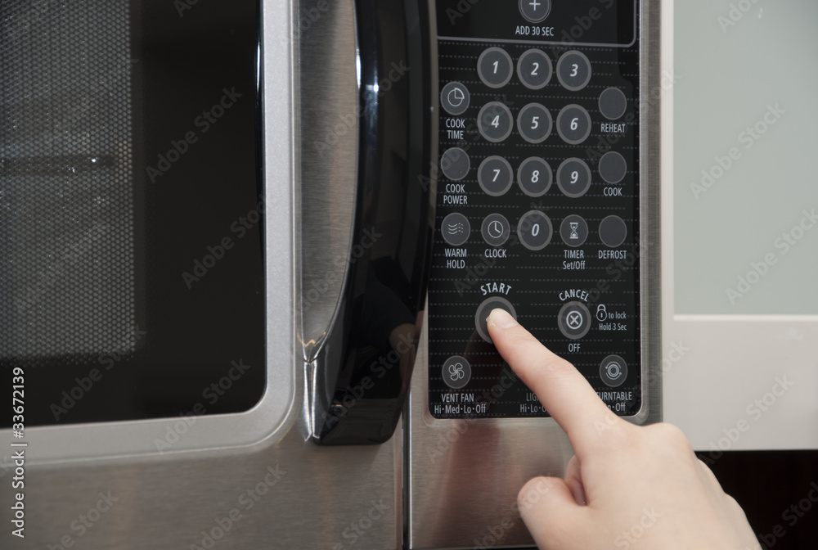

**Answers**

**Q1**. B

**Q2**. A

**Q3**. A

**Q4**. A

**Q5**.

* All buttons are the same colour making it hard to distinguish between them for visually impaired users.
* The control panel is flat for ease of cleaning, but this means the tactile interaction with buttons is lost making it harder to navigate around the panel for visually impaired users.
* The use of grey for all buttons makes it hard for children or visually impaired to distinguish between controls.
* As all buttons are the same shape distinguishing between them is very difficult.
* The white text on dark grey background means that it is easier to read for most users (not just the visually impaired).
* It is not clear how to change features such as power settings or length of time with the current buttons.
* Some buttons have distinct logos which make it easier to understand their function